**APCSP Activity 1.4.4: Python Imaging Library API**

Learning Target: Define the problem and analyze research to create a solution to a problem.

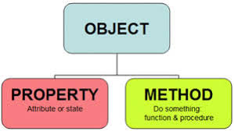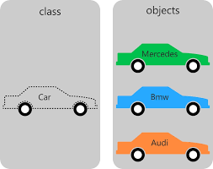

**Step 4**

Explain the purpose of the outer for loop:

Outer for loops like that are usually used when dealing with 2 dimensional arrays or something with a similar structure. So for example if you have arr[[1.1, 1.2, 1.3][2.1, 2.2, 2.3][3.1, 3.2, 3.3]] you would usually use nested for loops to loop through this type of object as if it was a 2 dimensional grid.

Explain the purpose of the inner for loop:

Like I explained before the inner for loop would be used within another for loop and potentially nested within several if statements and would be used to run through one of the 2 dimensions that is in the 2 dimensional array.

Explain the purpose of the if statement.

To filter certain actions so array data would only be processed if specific requirements are met.

**Steps 5-7**

Refer to Table 2 in the Reference Card for Pyplot and PIL to give a short description for the methods listed below. For the final three rows of the chart, identify three methods of the objects in the PIL.Image class that are not yet listed in the table. Additionally, add another attribute of every PIL.Image object to the second chart.

|  |  |
| --- | --- |
| Method | Short Description |
| open() | Opens an image from a specific path to be used later in the program |
| new() | Creates a new image with the provided mode, size, and optionally color |
| crop() | Makes a PIL.Image of smaller size |
| convert() | Converts an image to another mode, and returns the new image. |
| resize() | Returns a resized copy of an image. The size argument gives the requested size in pixels, as a 2-tuple: (width, height) |
| rotate() | Returns a copy of an image rotated the given number of degrees counter clockwise around its center. |
| paste() | Pates another image into the current image. The box argument is either a 2-tuple giving the upper left corner, a 4-tuple defining the left, upper, right, and lower pixel coordinate, or None (same as (0, 0)). If a 4-tuple is given, the size of the pasted image must match the size of the region. |
| transform() | Creates a new image with the given size, and the same mode as the original, and copies data to the new image using the given transform. |
| save() | Saves the image under the given filename. If format is omitted, the format is determined from the filename extension, if possible. This method returns None. |
| blend() | Creates a new image by interpolating between the given images, using a constant alpha. Both images must have the same size and mode. |
| composite() | Creates a new image by interpolating between the given images, using the corresponding pixels from a mask image as alpha. The mask can have mode “1”, “L”, or “RGBA”. All images must be the same size. |
| eval() | Applies the function (which should take one argument) to each pixel in the given image. If the image has more than one band, the same function is applied to each band. Note that the function is evaluated once for each possible pixel value, so you cannot use random components or other generators. |

|  |  |
| --- | --- |
| Attribute | Short Description |
| size | Width, height |
| mode | “1”, “L”, “RGB”, or “CMYK” (color format) |

**Step 11**

Summarize the purpose of the following three libraries:

|  |  |
| --- | --- |
| Library | Short Description |
| matplotlib.pyplot (plt) |  |
| numpy (np) |  |
| PIL |  |

**Step 13**

a. Line 15 calls the function open() from the PIL.Image library. The function is being called with one argument: student_file. The function returns one object, which is being assigned to student_img.

Line 16 calls the function ________ from the ________. The function is being called with ________ argument(s): ________ . The function ________ returns ________ object(s), which is/are being assigned to ________ .

b. In line 17, the imshow() method is called on the object axes[0]. Complete the chart to describe the following lines of code:

|  |  |  |  |
| --- | --- | --- | --- |
| Line 17 calls | imshow() | on | axes[0] |
| Line 20 calls |  | on |  |
| Line 21 calls |  | on |  |
| Line 22 calls |  | on |  |
| Line 23 calls |  | on |  |
| Line 24 calls |  | on |  |

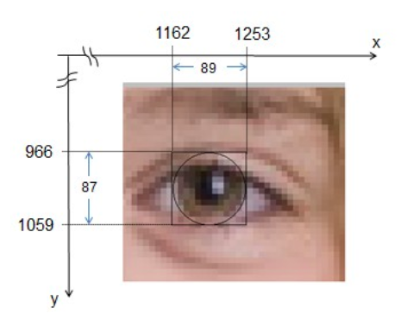

c. Lines 21-23 change the axes displaying the single right eye in the figure. This figure was used to identify the upper left coordinates (1162,966) of a bounding box containing the eye. A bounding box is a rectangle containing a particular part of an image. The bounding box for the right eye’s iris is illustrated below.

What are the (x,y) coordinates of the upper left corner of the bounding box?

|  |
| --- |
|  |

**Step 14**

b. Examine the image’s left eye using the window’s pan/zoom mode and record the following information:

|  |  |
| --- | --- |
| Upper left coordinates of the bounding box: |  |
| Lower right coordinates of the bounding box: |  |
| Width of bounding box: |  |
| Height of bounding box: |  |

**Step 15**

The following part of the source code creates the figure that shows two Earths. Read and analyze lines 26-33 of the code.

1. Line 27 uses the join() function from the os.path module. It is being passed ____ arguments. The value it returns is being assigned to the variable ____.
2. In line 28 the open() function of the PIL.Image module returns a new PIL.Image object, which is being assigned to the variable ____.
3. In line 29 the resize() method takes only one argument: a 2-tuple. Explain why there are two sets of parentheses in this line.

|  |
| --- |
|  |

1. Refer to the bounding box shown in step 13c. Explain the purpose of the (89,97) argument in line 29.

|  |
| --- |
|  |

f. Reading documentation can be difficult because the words are unfamiliar, even to the expert. Also, the information you need might be found in more than one place. Be persistent! As an example to show you how to piece together information from different places, refer to both of the following sources of PIL documentation to learn how to reduce the size of an image with the resize() method of PIL.Image objects.

<http://effbot.org/imagingbook>

Lundh, Fredrik. (2008). *Python Imaging Library*

<http://infohost.nmt.edu/tcc/help/pubs/pil/>

Shipman, John. (2013). *Python Imaging Library*

I. What is an additional argument that can be passed to the resize() method?

|  |
| --- |
|  |

II. What is the default value of that argument?

|  |
| --- |
|  |

III. Our code is downsampling the image from NASA. Downsampling means using fewer bytes to represent the data. What value of the optional argument is recommended for downsampling?

|  |
| --- |
|  |

**Step 16**

Explain the algorithm you think resize() might be using. You can it using English sentences, pseudocode, commented code, or any other appropriate method. However, your explanation should address details related to the three or four bytes accounting for each pixel in the Image object returned by the resize() method.

|  |
| --- |
|  |

**Step 18**

Add lines of code in the code editor to paste the Earth image onto the girl’s other iris. Take a screenshot of your code and final image.

|  |  |
| --- | --- |
| Code: | Image; |
|  |  |